## horizontal line



**Ware-wolf  
Data Wizards**

# Introduction

Retail companies are in the midst of a dynamic industry revolution. The internet and social media have given more power to consumers. Companies are searching for ways to improve revenue margins. To stay competitive, businesses are looking for ways to incorporate big data and automation into their process.

Ware-wolf is an Automated Inventory Management System that helps retail and food service managers track their stock in real time. Due to lower prices and advances in technology, businesses are adopting automated inventory management systems. Automated inventory management systems can streamline the inventory management process, increase data accuracy, save time, and increase sales. Our inventory tracking system, Ware-wolf, continuously updates and tracks your inventory on a real-time basis. It correlates with having a proper ordering system and supplier shipment system.

# Problems

1. The cost of traditional inventory labor is high and manual inventory data entry is time-consuming. The traditional inventory management system process includes manual data entry, data classification, data analysis, and data interpretation.
2. The most devastating inventory problem is overstocking and/or understocking. Overstocking and understocking bring economic losses and product waste.
3. Lower inventory results in missed sales due to replenishment time. To control and track the replenishment task managers can realize automatic inventory retrieval to simplify and optimize inventory management.
4. Stockroom product security is another concern with traditional inventory management. If products are removed by either employees or non-employees through unlawful methods, Ware-wolf will communicate with sales orders to identify possible theft.

# Solution

Ware-wolf monitors inventory in real time using AWS Deeplens. AWS Deeplens will replace the traditional inventory manager’s job. When new items arrive into the warehouse, the AWS Deeplens will send this information to Ware-wolf. Also, when items exit out of the warehouse, the AWS Deeplens will send this information to Ware-wolf. Ware-wolf will record all the inventory data for the store owner.

At the same time, Ware-wolf will help the store owner manage product security. When an item exits the store without authorization, Ware-wolf will send alerts to the appropriate authority.

In addition, Ware-wolf can help businesses owners prevent the loss in profits due to “out of stock” products. If the number of the products are less than predicted requirements, Ware-wolf will send alerts to the owner’s phone and help owners order more products at exactly the right time.

**Benefits**

* Saving labor costs and time
* Helping managers track Key Performance Indicators (KPIs) to understand the strengths and weaknesses of the business model
* Providing real-time product usage
* Tracking inventory accurately to improve sales
* Avoiding overstocking and reducing leftover products

# 

# Challenges

1. The recognition accuracy needs to be improved by machine learning. Data integrity and correctness are important factors in determining the performance of automated inventory management systems. When multiple tags simultaneously send data to the reader within the scope of the reader, or when one reader is within the scope of another reader, the signals interfere with each other, resulting in mutual interference. The data received by the detector is incorrect, that is, the label cannot be completely identified, or the wrong label is recognized.
2. Building a prediction data model needs to gather enough data of product to train the model on. We are using barcodes of each product for cameras to scan and recognize. Data capacity also has a tendency that expands ceaselessly. Although the cost of barcodes, readers and software have been falling, the cost of deploying remains unaffordable for many companies that want to track inventory. Presently, the application of this technology is hindered by the lack of enthusiasm on the part of enterprises to invest in this system.

# Requirements

## Data

We are collecting image data on products in the stock room. This data will be captured using AWS Deeplens technology. AWS Deeplens will be trained on product images through AWS Sageworks. This will allow AWS Deeplens to recognize products through video streams and update inventory counts in real time. Products are identified by the based on probability they are an inventory item. If over 85% then the item will be marked down as a verified item. The data will be stored in an AWS S3 storage account.

## High-Level Diagram

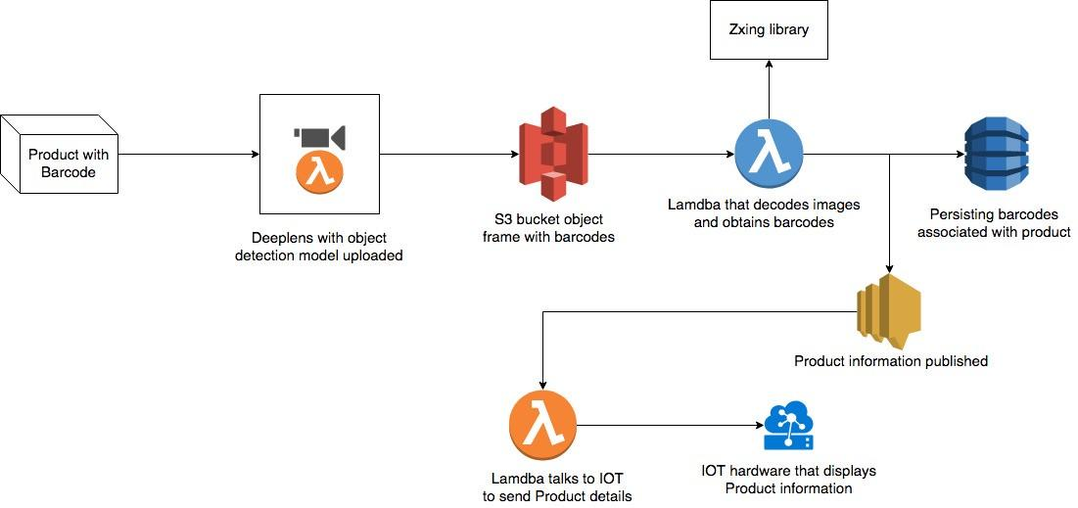

## 

## 

## Database

Ware-wolf will use a Big Data File System (AWS S3 Storage) to store the video data from the Deeplens camera. This video data is going to be stored for a short duration of time for the purpose of image recognition and will be deleted later to save storage space and resources. Metadata for products will be stored in Amazon DynamoDB. The Big Data File System will also be used to store other relevant product data like inventory usage patterns for further analysis.

## 

## Database Diagram

## 

## 

## 

## User Interface

Ware-Wolf needs to have a user-friendly interface that can be easily understood by non-technical users. Visual aids like graphs and pie charts will be used to visualize relevant data on the dashboard. There will be a simple menu with options that facilitate ease of use. Color-coded notifications will be displayed to notify the user of issues that need to be addressed. For example, the color red notifies the user of critical issues, yellow for moderate risk issues, and green for optimized operation. The User Interface will need to include the following features :

* Access to AWS DeepLens camera feeds
* Live Inventory Statistics
* Predict raw material/inventory requirements
* Product order automation, information and tracking
* Alerts and Notifications regarding stock levels

## Machine Learning

AWS Deeplens trains on data models through AWS Sageworks. We have to develop image recognition machine learning models to identify products and barcodes. The app needs to analyze object movements to differentiate between a product coming in or going out of the inventory. We also plan on storing and analyzing inventory usage pattern to predict stock requirements.

# 

# Cost and Resource Estimates

## Hardware / Software Costs

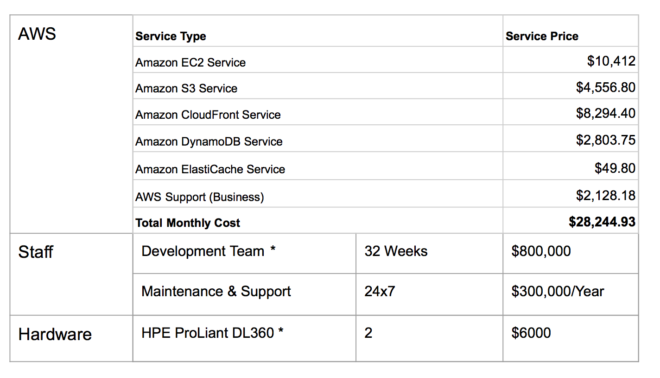

For the aims of this project, we will need a development team consisting of 1 Chief Technology Officer (CTO), 2 Data Scientist, 1 Cloud Developer, and 3 Full Stack developers. Also, the maintenance and support team consisting of AWS cluster administrator, Database administrator and Technical Support Assistant.

## 

## 

## Estimated Project Timeline

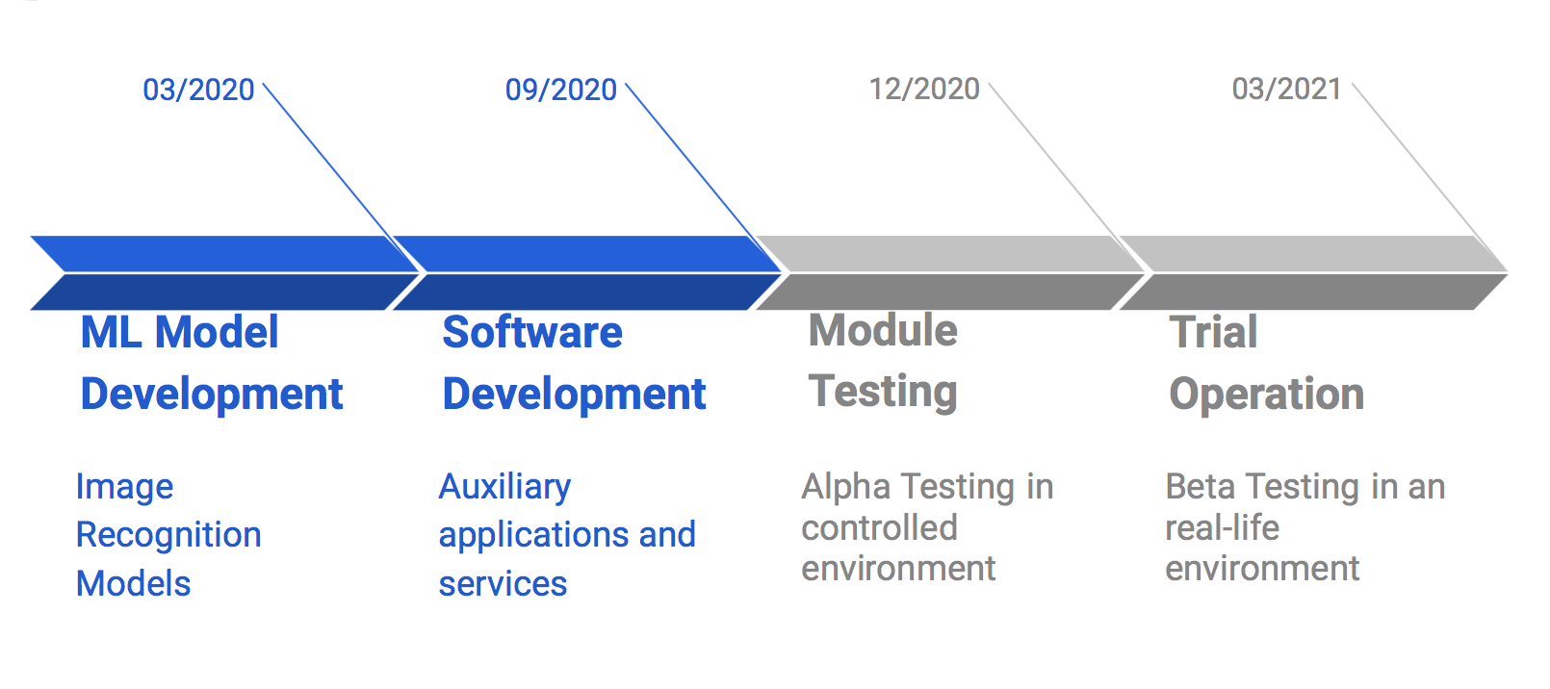

Based on the cost and resource estimates, our project will start with the development of high accuracy and performance machine learning models trained on product images to recognize products in the inventory. For the software development phase, we would do auxiliary applications and service to enhance the insights the deeplens analytics will provide. After the development phase, we will begin alpha testing the modules in a controlled environment. After that will conduct a series of beta tests in a real-life environment to identify bugs and patch them before rolling out the final version.

# 

# Risks

* System crash caused temporary inaccessibility of data
* Hacker malicious attack leads to data interruption
* Data storing: security and privacy
* Cost on backup and recovery procedures
* Training staff to use the system, need to support early adopters

## 

## Conclusion

Ware-wolf is developed to improve the operational efficiency of inventory management systems. The use of AWS Deeplens will allow managers of retail and food services to analyze and act upon consumer demand in an increasingly competitive landscape. The objective of investing in this management system is that businesses will diminish “time-to-insight” which can be the difference between a business that is able to profit and one that experiences stagnant growth (Sedkaoui & Soraya, 2019). Actionable insights can be provided to the managers of businesses so that they may better allocate the tasks of their employees. It is the Data Wizard’s belief that by harnessing the power of Big data we can support businesses in their aim of a more accurate inventory system that will better integrate buyers, sellers, and customers of retail and food service businesses. The enhanced understanding of customer’s needs in real-time as well as automatic updates will provide managers with better insight into their prospective success.

# 

# References:

"Award Winning Inventory Software." NetSuite. Accessed May 08, 2019. <https://forms.netsuite.com/app/site/crm/externalleadpage.nl?compid=NLCORP&formid=4624&h=AACffht_MEFDcBD4ls1xMArUwNErM3N69R0&redirect_count=1&did_javascript_redirect=T&leadsource=G547B8718AW&cid=ppc_g_24wd&gclid=Cj0KCQjwtr_mBRDeARIsALfBZA4UTeRHTzfRJCLdrFAgK0vEw4MQbpH-BVS7ReFbr8z6nT9gY1Bs7YMaAn8ZEALw_wcB>.

Cosgrove, Emma. "Automated Inventory Management Is Becoming a 'key Battleground'." Supply Chain Dive. August 14, 2018. Accessed May 08, 2019. <https://www.supplychaindive.com/news/automated-inventory-management-RFID/530071/>.

"Machine Learning Models & Algorithms | Amazon SageMaker on AWS." Amazon. Accessed May 08, 2019. https://aws.amazon.com/sagemaker/?nc2=h_m1.

Needle, Jessica. "Retail Safety Stock – Do You Even Need It?" Retail Inventory Optimization. Accessed May 08, 2019. https://blog.celect.com/retail-safety-stock-do-you-even-need-it.

Sedkaoui, Soraya. *Big Data Analytics for Entrepreneurial Success*. Hershey, PA: Business Science Reference, 2019.

"The Cloud as Catalyst for Retail." McKinsey & Company. Accessed May 08, 2019. https://www.mckinsey.com/business-functions/digital-mckinsey/our-insights/the-cloud-as-catalyst-for-retail.

"What Is AWS DeepLens?" Amazon. Accessed May 08, 2019. <https://docs.aws.amazon.com/deeplens/latest/dg/what-is-deeplens.html#how-deeplens-works>.